Gabriel Emerson

ELEC 2210 – T 11:00

Experiment #12 Amplifiers

04/06/2021

**Introduction:**

The goal of this lab is to use transistors and understand how to use them as amplifiers. A ZVN4306 N-MOSFET will be used to construct a four resistor bias circuit. The student will gain experience using the NI Elvis board and Multisim.

**Step 1: MOSFET Amplifier Biasing Network**

Using the prelab schematic and the ZVN4306, a four resistor biasing network was constructed. Voltage measurements were taken at the source, drain, and gate and then compared to the measurements taken during the prelab.

|  |  |  |  |  |
| --- | --- | --- | --- | --- |
|  | V­­D | VS | VG | VGS |
| Theoretical | 8.48V | 2.20V | 4.15V | 1.948V |
| Measured | 8.36V | 2.34V | 4.33V | 1.992V |

Table 1: Measured and Theoretical Values

**Step 2: MOSFET Amplifier**

Three capacitors were added to the network from Step 1. One at the input, one at the output, and one at the source resistor. Measurements were taken at various frequencies and voltages and the oscilloscope shows the amplification of the waveform. Drain Voltage and Source Voltage were specifically measured for a 5kHz, 1.3 Vpp sine wave. The graph of Vd shows a square wave with loose transitions. The peaks of which stay above the sine wave and the valleys stay below the sine wave. The graph of Vs shows a flat, almost DC-like signal. This is most likely due to the capacitor across Rs partially grounding the signal.

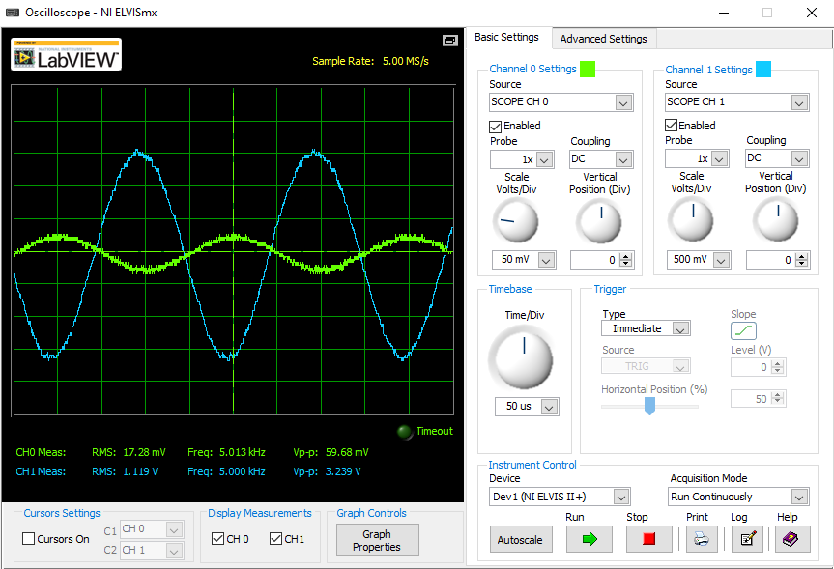

Figure 1: 5kHz; 0.05vpp; Gain: 54.27

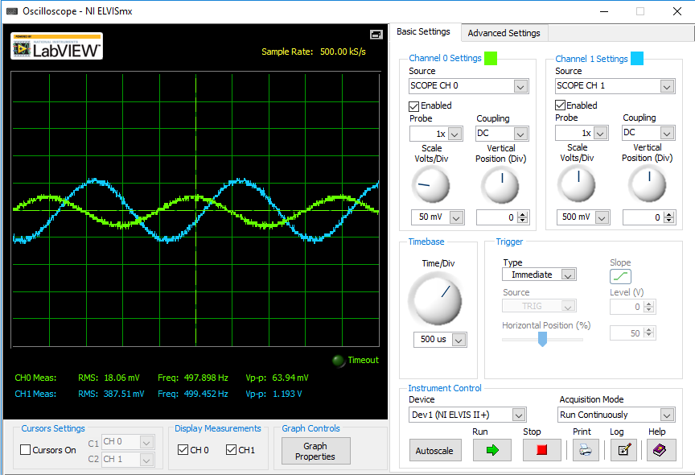

Figure 2: 500Hz; 0.05Vpp; Gain 18.66

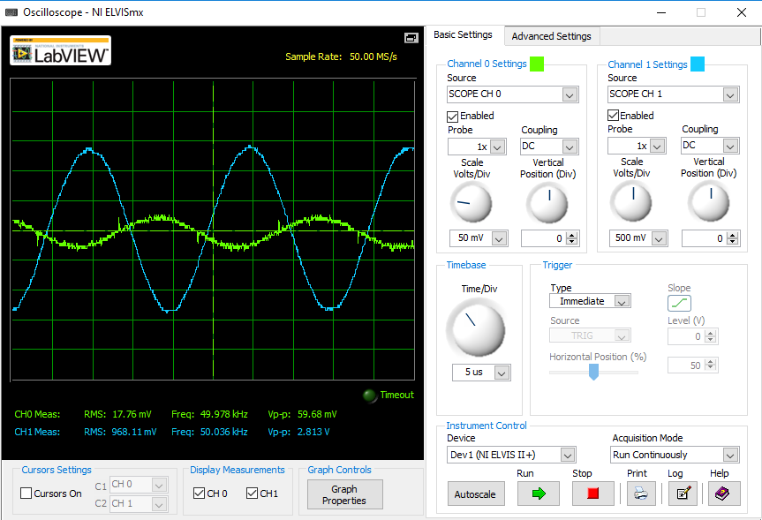

Figure 3: 50kHz; 0.05Vpp; Gain: 47.13

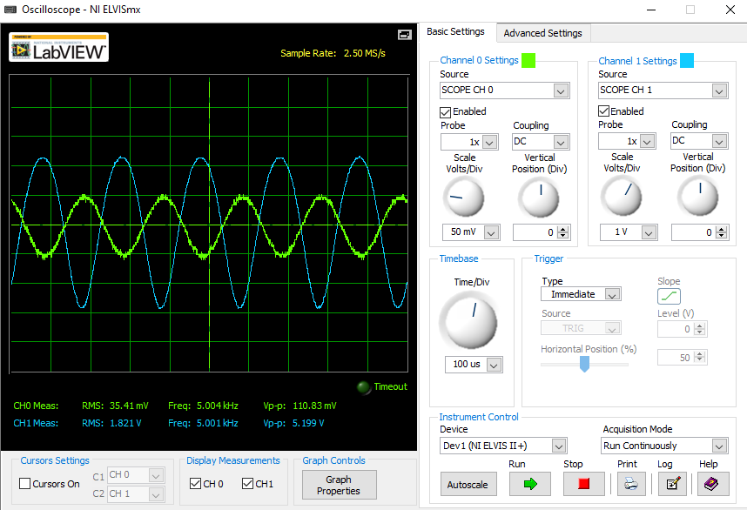

Figure 4: 5kHz; 0.1Vpp; Gain: 46.91

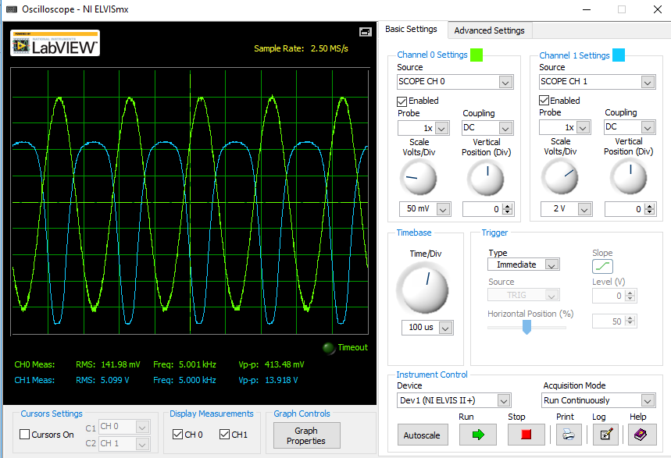

Figure 5: 5kHz 0.4Vpp; Gain: 33.66

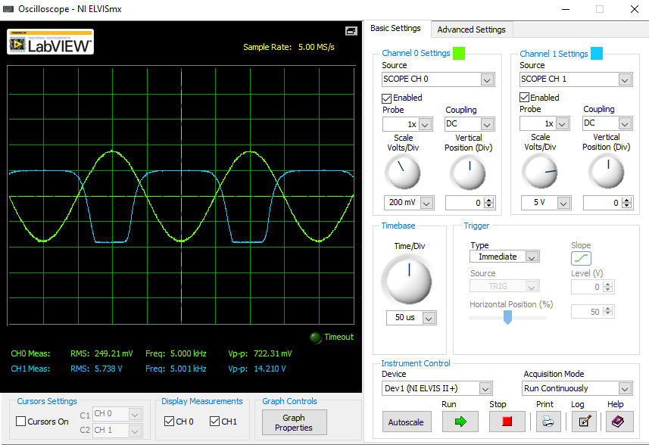

Figure 6: 5kHz; 0.7Vpp; Gain: 19.67

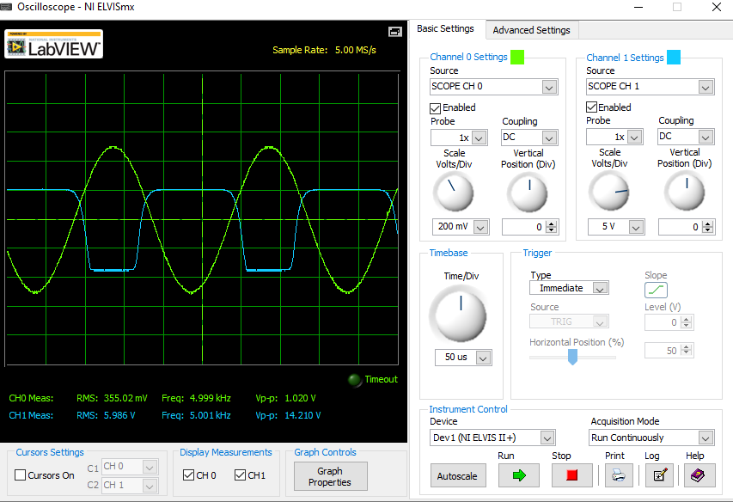

Figure 7: 5kHz 1.0Vpp; Gain: 13.93

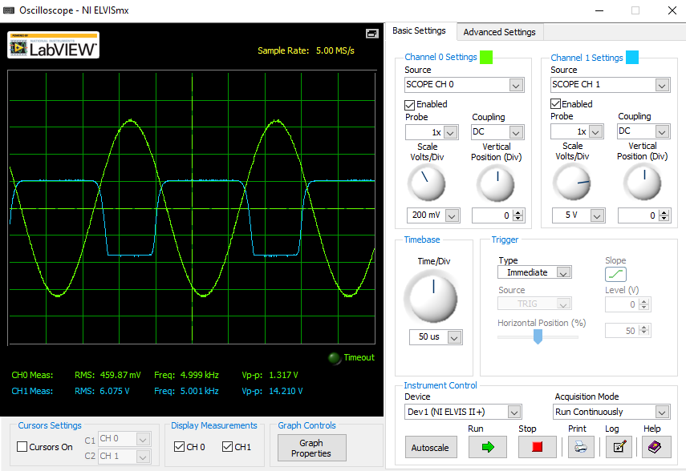

Figure 8: 5kHz; 1.3Vpp; Gain: 10.78

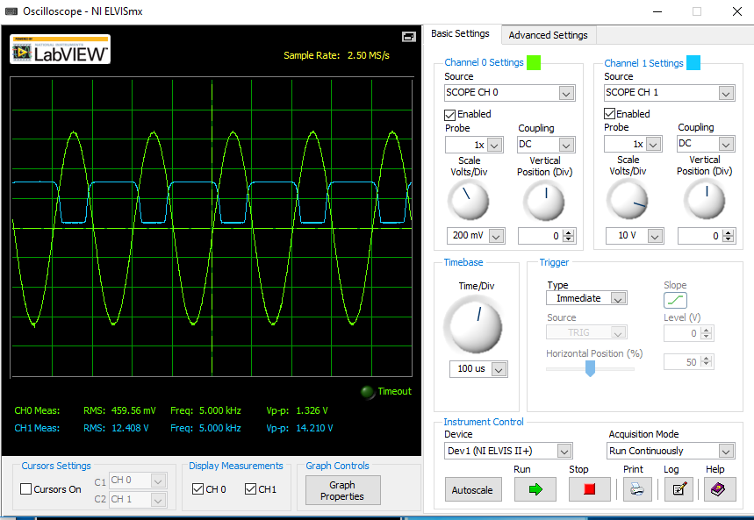

Figure 9: 5kHz 1.3 Vpp Drain Voltage

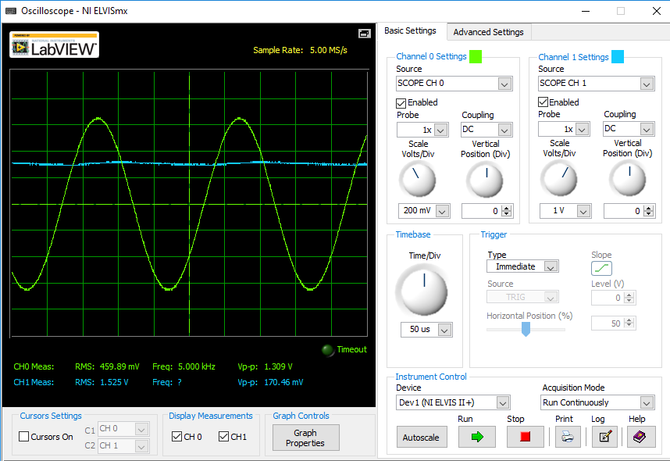

Figure 10: 5kHz 1.3 Vpp Source Voltage

Figure 11: Vin vs Gain Plot

**Step 3: Spectrum Analyzer**

Using the previous circuit network, the output signal spectrum was measured using the Spectrum Analyzer. The amplitude was increased until the output was clipping neat the peak and the valley. By increasing this amplitude, the total harmonic distortion (THD) was increased from 4.85% to 60.09%. The distortions can be seen in the following figures below.

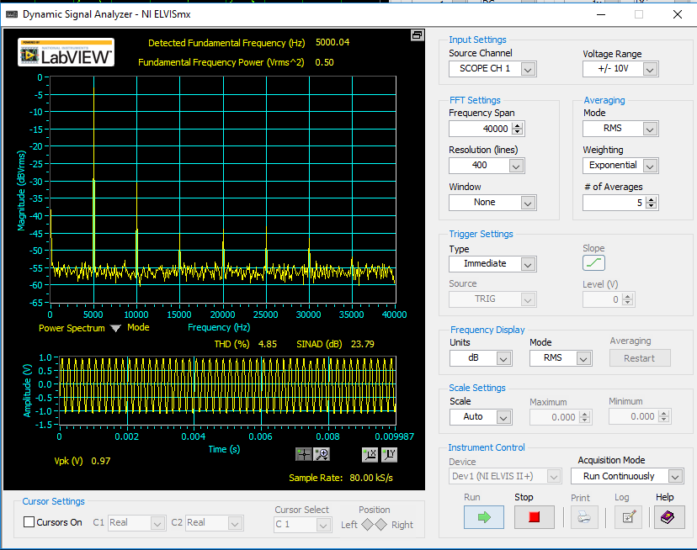

Figure 12: 5kHz 0.05Vpp Spectrum Analyzer

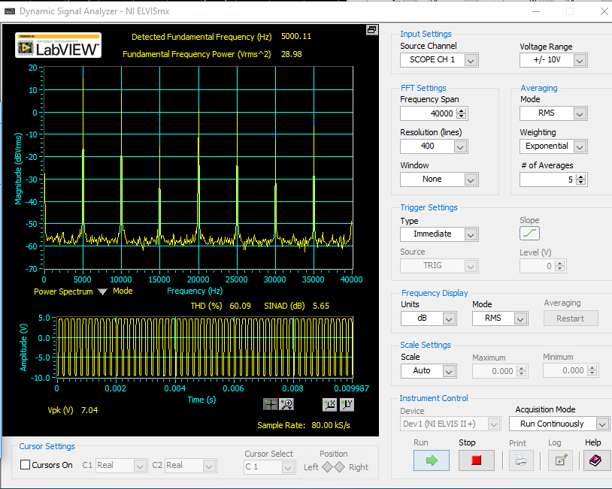

Figure 13: 5kHz 1.3Vpp

**Step 4: Bode Plot**

Using previous circuit network, the Bode Plot was used to capture the frequency response of the amplifier. The results from the plot were very similar to those simulated in the prelab.

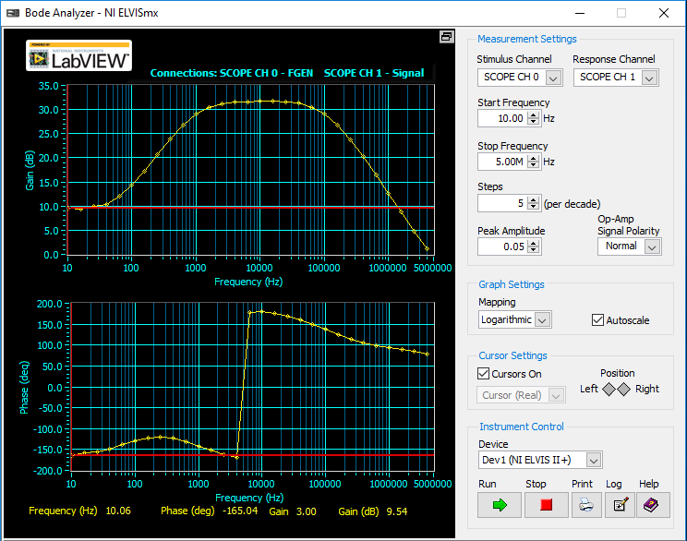

Figure 14: Bode Plot

**Step 5: Radio**

Using the previous circuit network, the input to the amplifier was replaced with a footlong wire that hung straight in the air, acting as a receiver. Another wire of similar length was attached to the function generator that acted as the radio signal generator. Using a 300kHz sine wave, the input signal of the function generator was sent through the wire and was picked up wirelessly by the receiver wire. This signal was then amplified as measured on the oscilloscope. The closer the wires were together, the larger the observed signal.

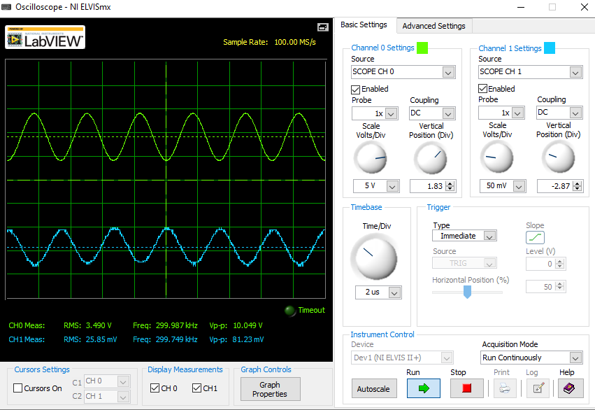

Figure 15: Amplified Radio Signal (Further Apart)

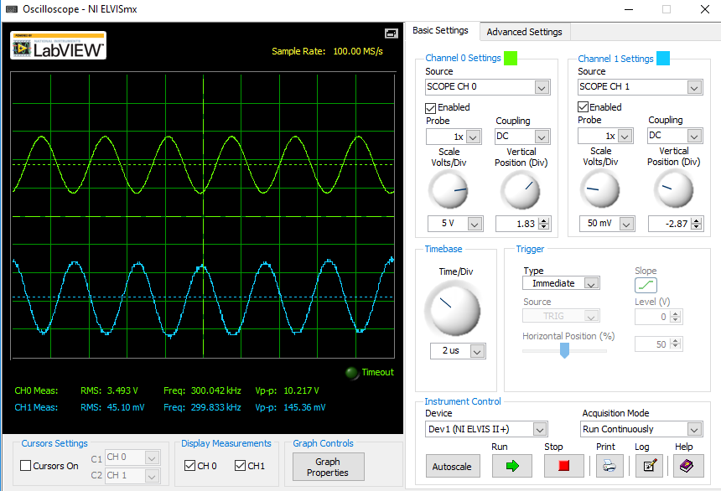

Figure 16: Amplified Radio Signal (Closer Together)

**Step 6: BJT Amplifier**

This step was rather simple. Instead of using the original transistor, replace it with a BJT and take measurements once again. This is done simply by removing the old transistor and putting the BJT in its place. The figures below are what I got from the BJT amplifier.

Figure 17: Amplifier with BJT

Figure 18: Spectrum Analyzer with BJT

Figure 19: Bode Plot with BJT

**Conclusion:**

This lab allowed me to gain a better understanding of amplifier circuits. This seems like it is a very helpful tool to have in future labs. The only part of the lab that I struggled with was finding the appropriate scaling values to use in Step 2. I spent more time in the lab trying to get each waveform to fit properly in the oscilloscope than I did wiring circuits. Other than that, I had no problems with the lab. I really enjoyed the radio signal step and I think future student might enjoy doing an entire lab on radios.

